**SAID SALAMA**

**SMART HOME PROJECT**

**PROF/DR SOBHY GOHNEIM**

**PROF/DR AHMED EMBABY**

**ENG TAHA SHERIF**

**I. INTRODUCTION:**

Home automation refers to providing the capability to control as well as monitor various household activities. Theses may include lighting, heating and air conditioning, security locks on the doors, multimedia, and various appliances. A home automation system can have varying degrees of intelligence and complexity. Automation of homes is adopted not merely to provide ease, convenience, and comfort to the user but also to minimize the energy waste and ensure home security. An ideal home automation system has the capability to sense its environment, process and act with minimal supervision. It is reliable, secure, user-friendly and cost effective. The home automation technology has witnessed remarkable growth and popularity over the past decade. In modern homes, various routine tasks have been automated for the benefit of the user. A simple example would be microwave ovens and automatic washing machines, which were introduced to reduce the manual labor. The home automation systems are not limited to lighting, HVAC and security systems, but have evolved into fire detection systems, entertainment systems and energy management systems as well. Currently, there exist various home automation technologies. The DTMF (Dual Tone Multiple Frequency) technology uses the DTMF tone generated by pressing a mobile phone keypad button to control devices. The main disadvantage of this approach is that the user will have to remember which key to press for each appliance he wants to control. In the free hand gesture control, a person should be present in front of the appliance he wishes to control and must gesture to turn on and turn off a device. The disadvantage associated is that normal hand movements may be interpreted as a gesture to control the device. Home Automation is gaining a lot of attention; however, due to the high cost, there are only a few houses that are smartly automated. As the devices are getting smarter, mobile communication technologies are becoming a part of automation systems. Baraka presented a system that used an Arduino and a hybrid system comprising both wireless Zigbee and wired X10 technologies. Withanage e presented a comparison of popular home automation technologies. The study identified performance and affordability factors of home automation systems. X10 is affordable, but not necessarily reliable. Z-Wave is expensive, but has high performance. Z-Wave is better compared to ZigBee based on Price performance and might be chosen over the latter. D developed a system for home appliance control using the SMS service provided by GSM network. The user could send an SMS to control and monitor the home appliances. The system implemented an ATmega32 microcontroller-based control module. The drawback of the system can be the running cost; the user will have to incur SMS expenses. A Home Automation model using X10 protocol was realized by Karatas and Aksoy. The model implementation used a microcontroller for data processing and is easy to use, simple, compact and low cost. Another Home Automation System using Wi-Fi technology was described by AlShafei and Hamed. The system provided a user-friendly control solution that was low-cost, covered a large area, and provided scalability. A design of a low cost and wireless Home Automation System was presented by Ramlee to provide support to the disabled and the elderly. It incorporated the use of a PIC microcontroller and a Bluetooth module to control the target appliances in the home. The system used two GUIs (Window an Android application) to provide simple control. Shah focused on the importance of power saving. A smart power saving system was suggested to minimize energy waste and provide comfort at the same time. They developed a system based on the use of a microcontroller and wireless communication. A module for Home Automation application was developed by Wijetunge. The concept was of a system general purpose to the developer rather than the end user. A set of electrical appliances were controlled with the help of Bluetooth communication. Bluetooth is the ideal way to use wireless communication between various devices in a home automation system. The Bluetooth technology operates over unlicensed and globally available frequency of 2.4GHz. The range of the Bluetooth technology is application specific and can vary from 10m to 100m, at a speed of up to 3Mbps, depending on class of radio used. This technology provides interoperability to the user. It enables the user to control various devices within the home with his smart devices using wireless communication giving the ability to monitor and control. Bluetooth technology based wireless communication makes Home Automation System flexible since it can be accessed in any geographical location as long as there is a Bluetooth connection between the system and control device (like a mobile phone, a tablet, or a PC), and they are within the Bluetooth network range. Also, Bluetooth based Home Automation System is safe from an internet hack or power failure.

**2. COMPONENTS:**

**Light Sensor An LDR:** (light dependent resistor) is used as a light sensor to measure the ambient light levels and input them to the MCU. An LDR is a light-controlled variable resistor. It exhibits photoconductivity. The resistance value of the LDR increases with decreasing incident light intensity levels and vice-versa. This photo-detector is ideal for lighting automation

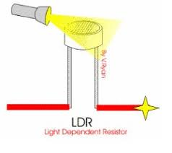 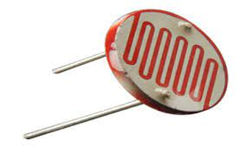

**Temperature Sensor:** The IC LM35 is used as a precision temperature sensor. It has an output voltage linearly proportional to the ambient temperature in Celsius and low output impedance. The LM35 is rated to operate over a −55°C to +150°C temperature range

In order to understand the working principle of LM35 temperature sensor we have to understand the linear scale factor. In the features of LM35 it is given to be **+**10mills volt per degree centigrade. It means that with increase in output of 10 mills volt by the sensor v out pin the temperature value increases by one. For example, if the sensor is outputting 100 mills volt at v out pin the temperature in centigrade will be 10-degree centigrade. The same goes for the negative temperature reading. If the sensor is outputting -100 mills volt the temperature will be -10 degrees Celsius.

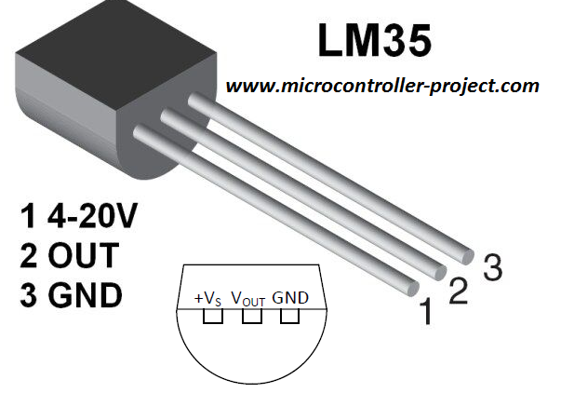

**Matrix Keypad:**

A 4x4 matrix keypad is used to input the password. If the password is correct, the door opens and the user can enter the house. Thus, the home automation system ensures safety of the home.

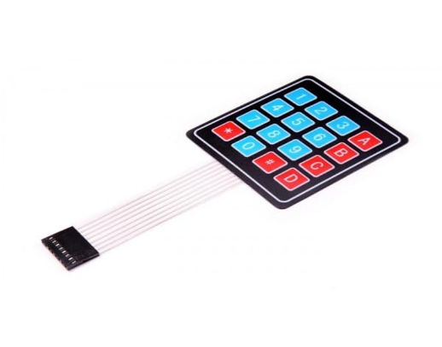

**Bluetooth Module:**

HC Bluetooth serial interface module HC-05 is used as to provide Bluetooth connectivity to provide wireless communication between a mobile phone device and home automation system. Default communication baud rate: 9600, and 1200-1.3M are settable. It uses UART serial communication protocol.

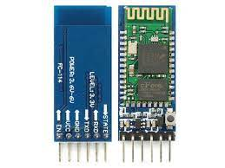

**Buzzer :**

A small buzzer is used to alert the user in case of a possible fire hazard.

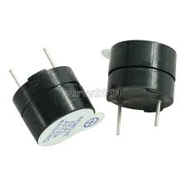

**Controller:**

A microcontroller is used to act as a brain to the home automation system. A microcontroller is a highly integrated chip where all the peripherals like CPU, timers, counters, RAM, ROM, registers, I/O pins, clock circuit, etc. are built in. Therefore, is a microcontroller is a combination of a microprocessor and peripherals. Microcontrollers are small, powerful and are used in embedded applications for specific tasks. In the smart home automation system, one ATmega32 microcontroller is used. It belongs to the Atmel’s family of microcontrollers. Atmel AVR microcontrollers provide flexibility in terms of design and no other microcontroller offers better power efficiency than the AVR family. The mega AVR device family offers a good amount of memory and inbuilt peripherals and is suitable for general purpose applications

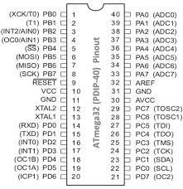

**LCD Display :**

A 16x2 LCD (liquid crystal display) is used as a basic electronic display screen. A 16x2 LCD means simply means that it can display 16 characters per line and there exist 2 such lines.

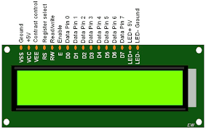

**Servo motor:**

Servo motor works on **the PWM (Pulse Width Modulation) principle**, which means its angle of rotation is controlled by the duration of pulse applied to its control PIN. Basically, servo motor is made up of DC motor which is controlled by a variable resistor (potentiometer) and some gears. In the smart home it is used for controlling the door open it or close.

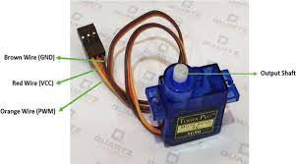

**RELAY MODULE:**

A power relay module is **an electrical switch that is operated by an electromagnet**. ... When electrical current is passed through a coil, it generates a magnetic field that in turn activates the armature. This movement of the movable contacts makes or breaks a connection with the fixed contact.We use it to control 220volts appliance with only 5 volts

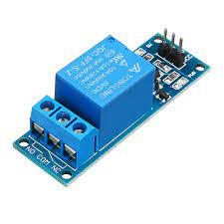

**3. CONTROL SYSTEM:**

In today’s scenario, most homeowners already have at least one smartphone having Bluetooth compatibility (or even a tablet, or PC for that matter). This makes the incorporation of a Bluetooth based Smart Home Automation system highly convenient. The proposed Smart Home Automation System incorporates the use of Bluetooth technology for wireless communication. The user can monitor and control their lighting, fan, and door lock and security system with the help of a user-friendly application. I had made use of Bluetooth terminal application available on Google Play Store. A connection is established between the mobile Bluetooth and Bluetooth module, using a 4-digit pass code. Next, the user inputs a character in the Bluetooth Terminal application. The character is then received by the Bluetooth Module in the HAS. The microcontroller reads the input character and performs the corresponding function.

I also provided for the homeowners to choose either controlled mode or automatic mode

In controlled mode the user can monitor and control their lighting, fan, and door lock and security system with the help of a user-friendly application as mentioned before but in the automatic mode we use the sensors to determine the temperature and light intensity of the environment and according to their value the fan and the Leds are turned on or off automatically.

The Smart home system is divided into 4 sub systems

1.security system

2. Lighting System

3. Heating and Air-conditioning System

4. Fire Detection System

I will explain each system in detail................

**1.Security system:**

The smart home automation system employs home security system to restrict the entry of any intruder into the house. A flowchart for the security system is given below. A 4x4 matrix keypad is connected to the microcontroller as an input and a servo motor is connected as an output pin of the avr and is controlled using PWM mode of the timer. The user must enter a password into the matrix keypad to enter the house. If the password entered is correct, the servo motor rotates, and the door opens. If the password entered is incorrect, the servo motor will not rotate, and the door will not open. The password is set by the homeowner during the programming stage. Therefore, any outsider cannot enter the house unless he knows the correct password. Thus, the security system ensures home security and prevents possible burglary and/or entrance of suspicious persons.

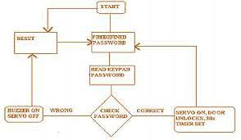

**The components used in this system are: 1. keypad 2. servo 3. Lcd**

1.keypad interfacing: At a lowest level, keyboards are organized in a matrix of rows and columns. The CPU accesses both rows and columns through ports, therefore with two 8-bit ports an 8 X 8 matrix of keys can relate to a microcontroller.

When a key is pressed, a column and a row make a contact; otherwise, there is connection between rows and columns. In x86 PC keyboards, a single microcontroller uses for software and hardware interfacing of the keyboard.

The below figure represents a 4 X 4 matrix connected to two ports. The rows are connected to an output port and the columns are connected to an input port. If no key has been pressed, reading the input port will give 1s for all columns since they are connected to high (VCC). If all the rows are grounded and key is pressed, one of the columns have 0 since the key is pressed provides the path to ground. It is the function of microcontroller to scan the keyboard continuously to detect and identify the key pressed

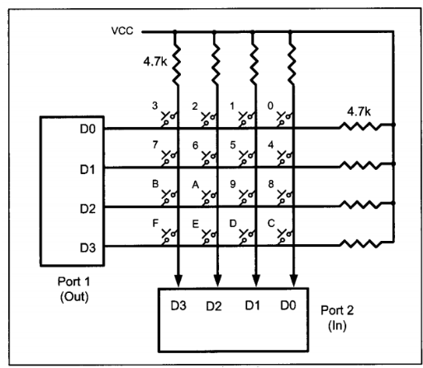

For detecting the pressed key, the microcontroller grounds all rows by providing 0 to the input latch, and then it reads columns. If the data read from the columns is D3-D0=1111, no key has been pressed and the process continues until a key pressed is detected by system.

However, if one of the column bits has a zero, this means that a key press has occurred. For example, if D3-D0= 1101, it means that a key in the D1 column has been pressed. After a key press is detected, the microcontroller will pass through the process of identifying the key.

Starting with the top row, the microcontroller grounds it for providing a low to row D0 only; then it reads the columns. If the data read is all 1s, no key in a row is activated and the process is further moved to the next row.

The process of identifying the rows and columns is easy as microcontroller knows at any time which rows and columns are being accessed.

CHECKING PASSWORD:

Whan a key of the keypad is pressed the proper character is printed on the lcd and is stored in an array; this is done 3times.

After this, the array now contains 3 elements, they are then compared with the password predefined in the code if it matches the door will be opened if not it will remain in the same position

To control the position of the servo motor we make use of PWM mode of timer

2.servo motor /PWM interfacing:

switching technique for providing intermediate amounts of electrical power between fully on and fully off levels. Usually, digital pulses have same on and off time period, but in some situations, we need the digital pulse to have more/less on time/off time. In PWM technique, we create digital pulses with unequal amount of on and off state to get required intermediate voltage values.

What is duty cycle? Duty cycle is defined by the percentage of high voltage duration in a complete digital pulse. It can be calculated by:

**% Of Duty cycle = T on /T (total time) x 100**

If the duty cycle is 50%, then it will remain on for exact half the duration of the total time period of the digital pulse.

The rotation angle of the servo motor is controlled by applying a PWM signal to it.

By varying the width of the PWM signal, we can change the rotation angle and direction of the motor.

At ~0.52ms duty cycle we get shaft position at -90° of its rotation.

At ~1.4ms duty cycle we get shaft position at 0° (neutral) of its rotation.

At ~2.4ms duty cycle we get shaft position at +90° of its rotation

To control servo motor in between -90° to +90° rotation. We need to generate a PWM waveform of 50Hz with duty cycle variation from ~0.5ms to ~2.4ms. We can use a fast PWM mode of ATmega16 using Timer1.

* Here we are generating PWM on the PD5/OC1A pin of ATmega16.
* We are using the 14th waveform generation mode of Timer1 in ATmega16, where TOP value for timer1 is decided by ICR1 register we can load TOP value in the ICR1 register, where timer1 overflow occurs and timer1 overflow flag gets set.
* We have used internal 8MHz clock frequency and FOSC/64 clock for timer1 we set 8MHz/64 = 125KHz clock for timer1.
* Now Fast PWM frequency formula is

#### **FPWM = FOSC / (N * (1 + TOP))**

Where N is pre-scaler divider 1, 8, 64, 256, or 1024.

* Hence to get 50Hz PWM frequency we need to load TOP value as 2499 so we get PWM frequency as,

#### **FPWM = 8000000 / ( 64 * ( 1 + 2499 ) )**

* So here we are loading ICR1 = 2499.
* Now just load OCR1A register values to get a compare match at the desired duty cycle.
* As here Timer1 clock is of 125KHz we get a one-timer count of 1/125 kHz = 8 us time period.
* Now suppose we want a PWM duty cycle period of 1ms , then we need to load the OCR1A register with 1ms/8us OCR1A = 125.
* So, load OCR1A register as per duty cycle period requirement.

For more details about the timer and different modes go to the datasheet .

3.lcd interfacing:

I used an LCD 16x2 is a 16-pin device which has 8 data pins (D0-D7) and 3 control pins (RS, RW, EN). The remaining 5 pins are for supply and backlight for the LCD.

The control pins help us configure the LCD in command mode or data mode. They also help configure read mode or write mode and when to read or write.

LCD 16x2 can be used in 4-bit mode or 8-bit mode depending on the requirement of the application. In order to use it, we need to send certain commands to the LCD in command mode and once the LCD is configured according to our need, we can send the required data in data mode.

In this project I used the LCd in 4-bit mode to reduce the number of wires required

* In 4-bit mode, data/command is sent in a 4-bit (nibble) format.
* To do this 1st send a Higher 4-bit and then send a lower 4-bit of data/command.
* Only 4 data (D4 - D7) pins of 16x2 of LCD are connected to the microcontroller and other control pins RS (Register select), RW (Read/write), E (Enable) is connected to other GPIO Pins of the controller.

Therefore, due to such connections, we can save four GPIO pins which can be used for another application.

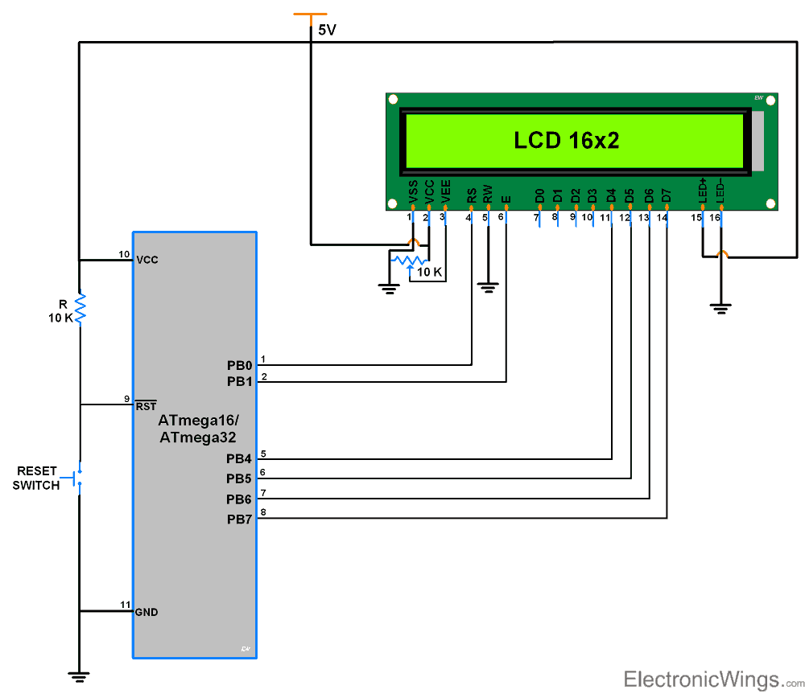

The code and driver of all components is shown at the end.

**2.Lightening system&&3. Heating and Air-conditioning System:**

Both systems have the same principle ,as I mentionned we can operate the sysytem in controlled or automatic mode we decide which mode by the mobile phone whivh communicate with the microcontroller via a bleutooth module which in return communicate with the controller using the serial communication protocol

**USART.**

AVR ATmega has flexible USART, which can be used for serial communication with other devices like computers, serial GSM, GPS modules, etc.

Before beginning with AVR USART, we will walk through the basics of serial communication.

While sending/receiving data, some bits are added for the purpose of knowing the beginning/ending of data, etc. commonly used structure is: 8 data bits, 1 start bit (logic 0), and 1 stop bit (logic 1), as shown

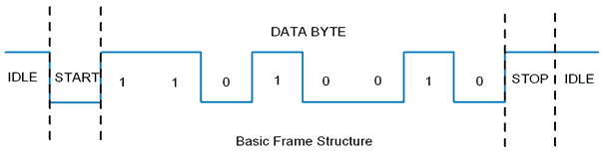

There are also other supported frame formats available in UART, like parity bit, **Speed (Baud rate)**

As we know the bit rate is “Number of bits per second (bps)”, also known as Baud rate in Binary system. Normally this defines how fast the serial line is. There are some standard baud rates defined e.g. 1200, 2400, 4800, 19200, 115200 bps, etc. Normally 9600 bps is used where speed is not a critical issue. In our project we did use 9600baud rate

variable data bits (5-9 data bits).

As stated in the datasheet ATmega 32 USART has the following features

* Full Duplex Operation (Independent Serial Receive and Transmit Registers)
* Asynchronous or Synchronous Operation
* Master or Slave Clocked Synchronous Operation
* High-Resolution Baud Rate Generator
* Supports Serial Frames with 5, 6, 7, 8, or 9 Data Bits and 1 or 2 Stop Bits
* Odd or Even Parity Generation and Parity Check Supported by Hardware
* Data OverRun Detection
* Framing Error Detection
* Noise Filtering Includes False Start Bit Detection and Digital Low Pass Filter
* Three Separate Interrupts on TX Complete, TX Data Register Empty, and RX Complete
* Multi-processor Communication Mode
* Double Speed Asynchronous Communication Mode

To program, first, we need to understand the basic registers used for USART

**AVR basic Registers**

1. **UDR: USART Data Register**

It has basically two registers, one is Tx. Byte and the other is Rx Byte. Both share the same UDR register. Do remember that, when we write to the UDR reg. Tx buffer will get written and when we read from this register, Rx Buffer will get read. Buffer uses the FIFO shift register to transmit the data.

2. **UCSRA**: USART Control and Status Register A. As the name suggests, is used for control and status flags. In a similar fashion, there are two more USART control and status registers, namely UCSRB and UCSRC.

3. **UBRR**: USART Baud Rate Register, this is a 16-bit register used for the setting baud rate.

This is the communication protocol I used then this protocol is used to communicate with HC-05 module which enable us to send characters and receive data to and from mobile.

1.CONTROLLED MODE

In the controlled mode the user has the abillity to control home appliances like lambs ,fans or any other appliance by the mobile phone as discussed

The follwing code shows how the controlled mode operate.....

char control;

{

char device;

usart_send_string("1-ROOM 2-FAN 3-Exit mode");

control=usart_read();

while(control!='3')

{

if(control=='1')

{

usart_send_string(" Room: 1-ON 2-OFF");

device=usart_read();

if(device=='1')

{

TURN_ON_ROOM1();

}

else if(device=='2')

{

TURN_OFF_ROOM1();

}

}

else if(control=='2')

{

usart_send_string("Fan: 1-ON 2-OFF");

device=usart_read();

if(device=='1')

{

TURN_ON_FAN();

}

else if(device=='2')

{

TURN_OFF_FAN();

}

}

usart_send_string("1-ROOM 2-FAN 3-Exit mode");

control=usart_read();

}

The function called Usart_read() permit us to read the characters from the mobile and according to the sent characters the controller will excute a precise function

2.AUTOMATIC MODE

In the automatic mode the home appliances are turned on or off acording the readings of temperature and light sensors.

Both sensors use ADC

In the real world, analog signals are signals that have a continuous sequence with continuous values (there are some cases where it can be finite). These types of signals can come from sound, light, temperature and motion. Digital signals are represented by a sequence of discrete values where the signal is broken down into sequences that depend on the time series or sampling rate (more on this later). The easiest way to explain this it through a visual! Figure 5 shows a great example of what analog and digital signals look like.

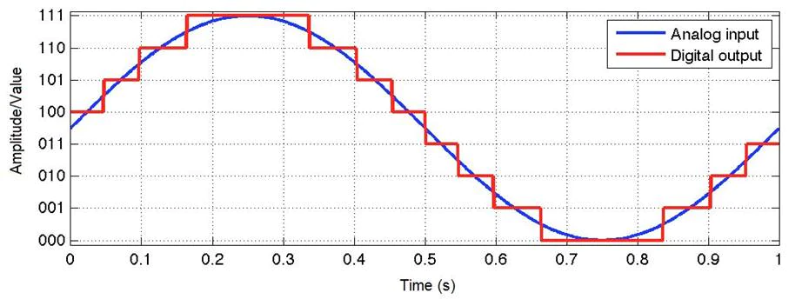Figure5

[Microcontrollers](https://www.arrow.com/en/categories/microcontrollers-and-processors/microcontrollers) can’t read values unless it’s digital data. This is because microcontrollers can only see “levels” of the voltage, which depends on the resolution of the ADC and the system voltage.

ADCs follow a sequence when converting analog signals to digital. They first sample the signal, then quantify it to determine the resolution of the signal, and finally set binary values and send it to the system to read the digital signal. Two important aspects of the ADC are its sampling rate and resolution.

ATmega16/32 supports eight ADC channels, which means we can connect eight analog inputs at a time. ADC channel 0 to channel 7 are present on PORTA. i.e. Pin no.33 to 40

The controller has 10 bit ADC, which means we will get digital output 0 to 1023.

i.e. When the input is 0V, the digital output will be 0V & when input is 5V (and Vref=5V), we will get the highest digital output corresponding to 1023 steps, which is 5V.

So controller ADC has 1023 steps and

Step size with Vref=5V : 5/1023 = 4.88 mV.

Step size with Vref=2.56 : 2.56/1023 = 2.5 mV.

So Digital data output will be Dout = Vin / step size.

The adc of the avr has the follwing features:

* It is 10-bit ADC
* Converted output binary data is held in two special functions 8-bit register ADCL (result Low) and ADCH (result in High).
* ADC gives 10-bit output, so (ADCH: ADCL) only 10-bits are useful out of 16-bits.
* We have options to use this 10-bits as upper bits or lower bits.
* We also have three options for Vref. 1. AVcc (analog Vcc), 2. Internal 2.56 v3. External A*ref*. Pin.
* The total conversion time depends on crystal frequency and ADPS0: 2 (frequency devisor)
* If you decided to use AVcc or Vref pin as ADC voltage reference, you can make it more stable and increase the precision of ADC **by connecting a capacitor between that pin and GND**.

I have programmed the adc register to work with the desired Vref and pre-scalar you can check the code and DATASHEET

When reaching a particaular degree of temperature or light the fan and the lamb will be turned on and if this value decreases the fan and lamb will turn off again.

The follwing code shows how the controlled mode operate......

void Automatic_mode()

{

usart_send_string("You are in Automatic mode\n");

usart_send_string("press any key to exit mode\n");

int x;

char temperature[3];

int y;

char light[3];

while(!(UCSRA&(1<<RXC))) // loop until any data sent from mobile(UART)

{

adc_init(0); // initialize adc for temp sensor with interrupt

x=read_adc(0);

ADC=0;

itoa(x,temperature,10);

LCD_Command(0x80);

lcd_print("Temperature =");

lcd_print(temperature);

if(x>35)

{

TURN_ON_FAN();

}

else

{

TURN_OFF_FAN();

}

_delay_ms(1000);

adc_init(1); //initilaize adc for ldr sensor without interrupt

y=read_adc(1);

ADC=0;

itoa(y,light,10);

LCD_Command(0xc0);

lcd_print("Light =");

lcd_print(light);

if(y>200)

{

TURN_OFF_ROOM1();

}

else

{

TURN_ON_ROOM1();

}

_delay_ms(1000);

}

LCD_Command(clear);

}

**4.Fire detection system**

The smart home automation system also incorporates a fire detection system to alarm the user of a possible fire hazard. This mode uses the same temperature sensor from the heating and air-conditioning mode of automation. A buzzer is connected as an output to the microcontroller. The microcontroller will set the alarm (buzzer) as soon as the ambient temperature increases to dangerously high level. This mode of home automation ensures the safety of the occupants of the house.

This sub system is the most important of all the systems since a possible fire can damage all the systems so the controller must respond as soon as possible to any detection of fire .

As we know that the code in round robin architecture is excuted line by line ,for detecting a fire we have to check the temperature continiuosly but if a function is being excuted and fire occurs at the same time ,the microcontroller wont be able to detect it till the function is finished,so we can not use this architectue Ihad to use RTOS

A Real Time Operating System, commonly known as an RTOS, is a software component that rapidly switches between tasks, giving the impression that multiple programs are being executed at the same time on a single processing core.

In actual fact the processing core can only execute one program at any one time, and what the RTOS is actually doing is rapidly switching between individual programming threads (or Tasks) to give the impression that multiple programs are executing simultaneously.

In a pre-emptive system each Task is given an individual priority value. The faster the required response, the higher the priority level assigned. When working in pre-emptive mode, the task chosen to execute is the highest priority task that is able to execute. This results in a highly responsive system.

So we have to create a task that checks the temperature with the highest priority, in this task we will check the temperature if a fire is detected the alarm function will be excuted till the temperature reduces again but if there is no fire this task will call a delay function to enable the excution of the other tasks of the system , and after the delay time passes the microcontroller will excute the task aving the highest priority again which is the fire detection task.

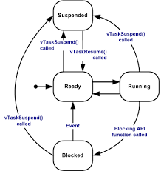

**4.RESULTS AND DISCUSSION**

Home automation is a developing technology. Automation of homes makes life easier and also alleviates the problem of energy waste, thereby reducing expenses. There are various home automation technologies each with their own pros and cons. In today’s world, there is a developing trend of incorporating smartphone and other such devices into Home Automation Systems. Since, most of these smart devices are Bluetooth compatible, it makes good sense to use Bluetooth technology for wireless communication. The proposed smart home automation system facilitates assistance services such as the monitoring of environmental parameters, and offers a manageable control of home automation devices. The proposed Smart Home Automation System is designed to provide lighting and temperature control, security and fire detection. The LDR senses the change in the light intensity level with a tolerance of ±5% and the temperature sensor senses the change in temperature within a tolerance of about ± 3% of the given threshold temperature . The Bluetooth module range is limited to up to 30feet. Overall, the system provides the user with a centralized control through his mobile device via a Bluetooth connection.

Kaur presented a Home Automation System that incorporated two control units, one for internal system and one for external system. The system offered password based locking system, light saving system and fire detection similar to the security system, lighting system and fire detection system presented in this study. The system also offered a counter dependent automatic switching system for lighting and temperature of the room and smoke detection not presented in this study

Similar to the proposed Smart Home Automation System in this study, Panth and Jivani designed a Home Automation System to control home appliances using Bluetooth technology. The system used an Android application to exchange ASCII data wirelessly with the control circuit through the Bluetooth facility of mobile phone. Unlike this study, Panth and Jivani developed their own interactive Home Automation System application using Android platform.

Ramlee presented the design of a Home automation System that provides three types of physical control methods to the Main Control Board. Similar to this study, two of the control methods provided wireless remote control of appliances to the PC/laptop user and the smartphone user. Unlike this study, the third control method provided low voltage switches that exclude the electrical shock hazard by use of a wet hand. Similar to this study, Narayan and Gayathri introduced an intelligent home automation system based on wireless communication technology. However, unlike this study, which incorporates the use of Bluetooth technology for control of client units, the system made use of a voice recognition module along with ZigBee technology to control electrical appliances. Also, the system could alert the user through an SMS in case of a fire hazard with the use of a smoke detector.

**5.CONCLUSION**

The proposed Smart Home automation System performs several tasks with minimal supervision. The system intelligently alters the brightness of the room in accordance with the outside daylight. The system offers temperature control with the help of the temperature sensor. Also, the system alerts the user as soon as the ambient temperature falls above the normal temperature range, suggesting the case of a possible fire hazard. The system ensures security of the home and prevents the entry of any intruders into the house. The system also provides control of devices via a smart device through the use of Bluetooth technology.

**6.CODE**

#include "FreeRTOS.h"

#include "croutine.h"

#include "task.h"

#include <avr/io.h>

#include <avr/interrupt.h>

#include "GPIO_AVR.h"

#include "GPIO_AVR_PORTS.h"

#include "LCD.h"

#include "keypad.h"

#include "Smart home1.h"

#include "UART.h"

#include <util/delay.h>

void Smart_Home_System(void*par);

void Fire_Detection_System(void*par);

int main(void)

{

lcd_init();

keypad_init();

Enter_Home();

PWM_Init();

Open_The_Door();

_delay_ms(3000);

Close_The_Door();

xTaskCreate(Smart_Home_System,(signed char *)"smart home",configMINIMAL_STACK_SIZE,NULL,1,NULL);

xTaskCreate(Fire_Detection_System,(signed char *)"fire",configMINIMAL_STACK_SIZE,NULL,2,NULL);

vTaskStartScheduler();

while(1)

{

}

}